**M3 – Assess the effectiveness of data transfer over wired and wireless networks.**

**Introduction**

In this assignment, I will assess the effectiveness of data transfer over a wired and wireless network. This means that I will explain how data transfers over a computer which is wired and a phone which is wireless.

**Wired**

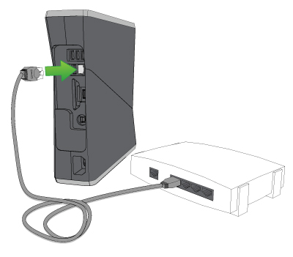A wired connection is mainly used by wired connection. It is really fast as they are no interruptions between the networks. Wireless is within a range and portable, but wired connection is not portable nor within range. Sometimes within the wireless connection, the user can face WAP problems, but wired connection is not like that. It uses a wired connection and it is very fast by using an Ethernet cable. Security is secure because they are a number of procedures to get into the network through the wired connection.

**Advantage**

* Fast connection. The user can use the computer very fast
* Secure connection

**Disadvantage**

* Portable – only can use the wired connection in one spot. You cannot take it around like a wireless connection

**Wireless**

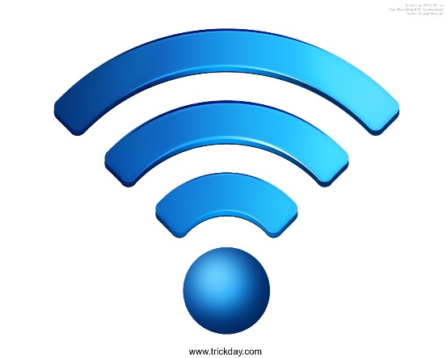Wireless does not use any sort of cables to transmit data. It uses signals to transfer data from one end to another. For example, if I use my mobile Bluetooth to send an image from one end to another, it will be done wirelessly. Therefore, I will need both devices to be close to each other. You will need a router because it allows internet access for you to transfer data to another computer e.g. sending an email to another person. Figure 1.1 is the logo of wireless. This determines the connection of the network. If it is 3 bars, the connection is working perfectly.

Figure 1.1

**Advantage**

* Portable – the user can use it anywhere. This would enable connection within the range

**Disadvantage**

* It has to be used within the range of the connection

**Problem for wired and wireless network**

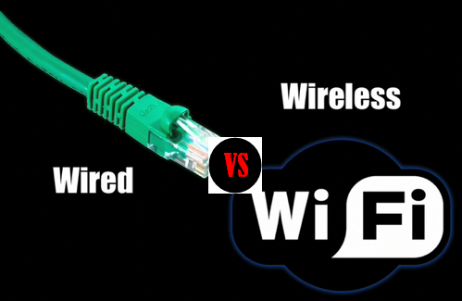They are a number of problems for wireless connection is that a computer could face during the ‘ping test’ is that we tried to communicate with another computer and it was not working with it. We typed in the IP address for one of the computers and it was not working for it. Another problem for wired connection is that if the one of the wires is not working, it would prevent the communication between the two computers.